A000-Indo-Borneo-Malaysia-Pensiangan-Head, Anthropomorphic-Mammoth Bone-18,000 BP

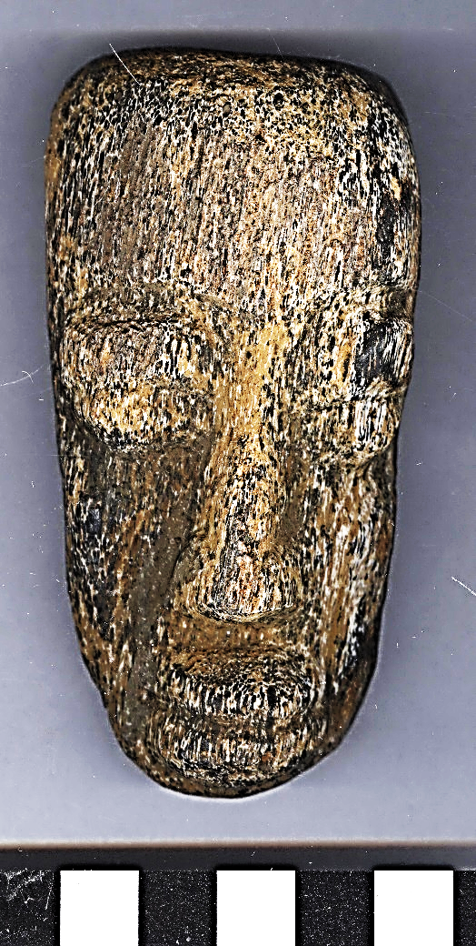 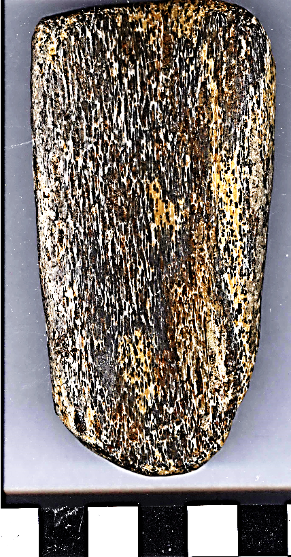

Indo-Borneo-Malaysia-Pensiangan-Head, Anthropomorphic-Mammoth Bone-18,000 BP

**Case No.: 1**

**Formal Label:** Indo-Borneo-Malaysia-Pensiangan-Head, Anthropomorphic-Mammoth Bone-18,000 BP **Display Description:** This anthropomorphic head of fossilized mammoth bone from Borneo attests to the fact that Sunda and Sahul provided a corridor for probocideans during the previous galacial maxima (LGM) of 60,000 BP, 30,000 BP and 18,000 BP. This sculptured anthropomorphic head depicts an individual with closed eyes, which implies it is either depicting an individual (i.e., a shaman) in a trance state or that the individual depicted is deceased and, hence, this sculpture is associated with a form of ancestor worship.

**Accession Number:**

**LC Classification:** QL754 .F38

**Date or Time Horizon:** 18,000 BP

**Geographical Area:** Borneo-Malaysia-Pensiangan

**Map, GPS coordinates:** 4.53375 116.30630; 40° 26' 46" N 79° 58' 56" W

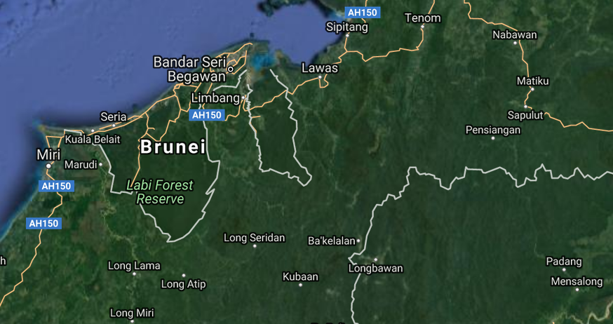 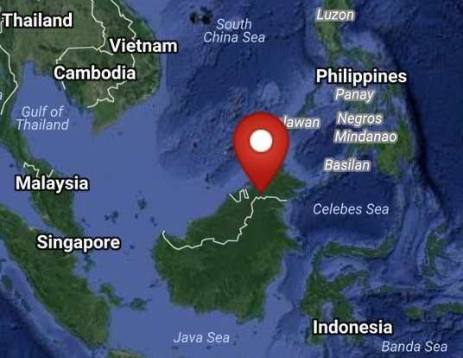

**Cultural Affiliation:** Borneo

**Medium:** Mammoth bone

**Dimensions:**

**Weight:**

**Condition: original**

**Provenance:** Pensiangan

**Discussion:** The now extinct Javan elephant(*Elephas maximus sondaicus*) colonized ne Borneo 300,000 BP based on MtDNA (Mitochondrial DNA) evidence, and this species developed separately. Simultaneously, its predecessor, *Mammuthus mammuthus*, also migrated toward ne Borneo. Land bridges that linked Borneo with the other Sunda Islands and the Asian mainland disappeared after the LGM 18,000 BP (Fernando *et alii* 2003). During the period 300,000 BP-18,000 BP, *Elephas maximus sondaicus* competed with *Mammuthus mammuthus* until the latter was driven to extinction by climate change based on paleontological and folkloric evidence of the long-term proboscidean habitation in ne Borneo (Shim 2003).

**References:**

Shim, P.S. 2003. “Another look at the Borneo elephant,” *Sabah Society Journal* 20: 7–14

Fernando P.; Vidya T.N.C.; Payne J.; Stuewe M.; Davison G. Alfred, R.J.; Andau, P. Bosi; E. Kilbourn; A. Melnick, D.J. 2003. “DNA Analysis Indicates That Asian Elephants Are Native to Borneo and Are Therefore a High Priority for Conservation,” *PLoS Biol*. **1** (1): e6